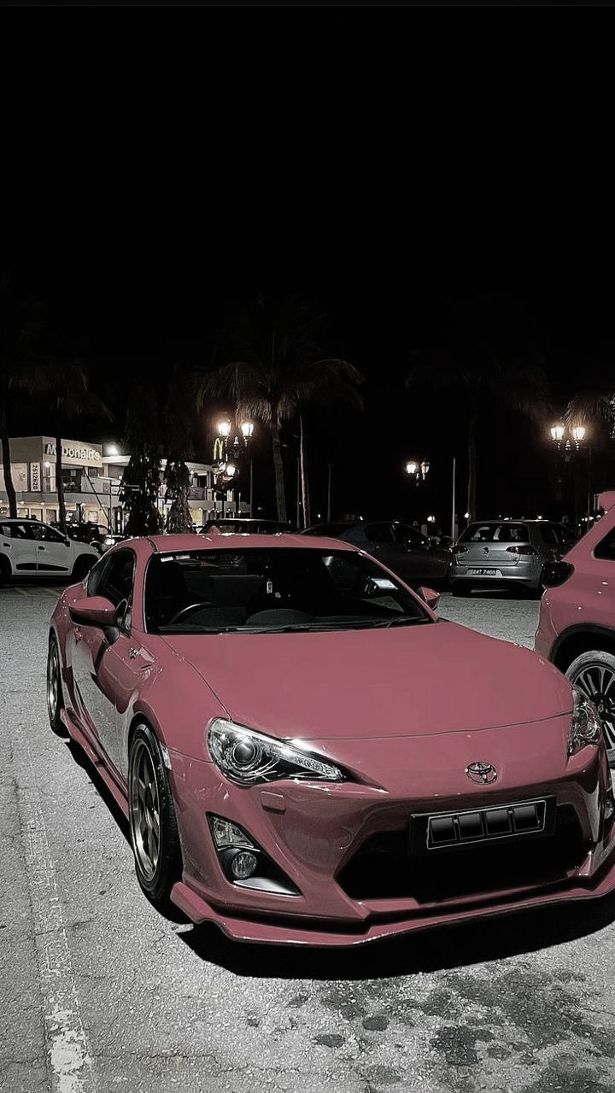

This ISSUE is

FEATURING Cutting Edge Automobile Technologies Updates and MORE

**THE PEOPLE’S CARS**

DECEMBER ISSUE

**BEYOND THE GEAR**

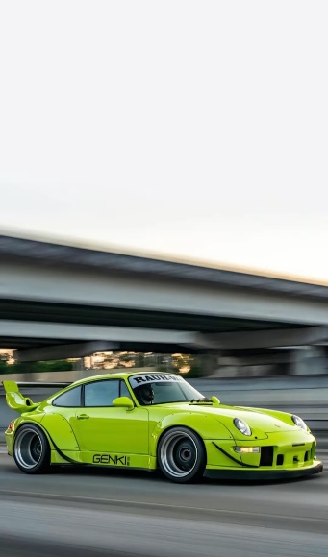

CONTENTS

**INTRODUCTION**

**LAMBORGHINI**

**THE EPITOME OF LUXURY AND SPEED**

**MERCEDES BENZ**

**PINNACLE OF ELEGANCE AND INNOVATION**

**AUDI**

**THE LEGACY OF INNOVATION AND RELIABILITY……**

**HYUNDAI**

**PIONEERING PROGRESS**

**TOYOTA**

**DRIVING INNOVATION AND TRADITION**

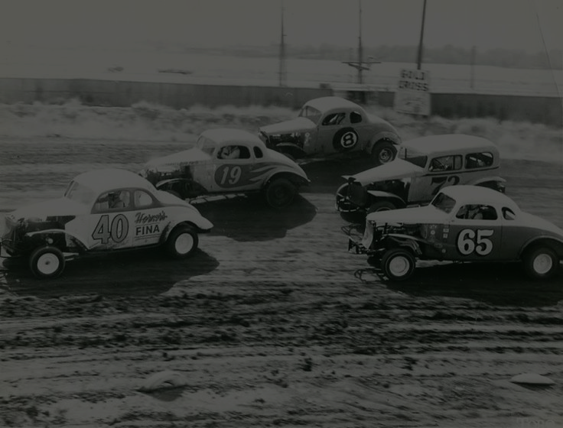

**INTRODUCTION**

Cars have revolutionized the way humans live, work, and travel. From their humble beginnings as steam-powered vehicles to the advanced, tech-driven machines of today, cars have become a symbol of innovation and progress. Beyond transportation, they represent freedom, individuality, and a connection to the open road.

The invention of the automobile in the late 19th century paved the way for rapid technological advancements. Over the decades, cars have evolved in design, performance, and efficiency, adapting to changing consumer needs and environmental concerns. Today, the automotive world continues to push boundaries, exploring electric power, autonomous driving, and sustainable materials.

Cars are more than just machines; they are works of art, engineering marvels, and a testament to human ingenuity. This magazine takes you on a journey through the fascinating history and stories behind some of the most iconic vehicles ever created. Buckle up—it's going to be an exciting ride!

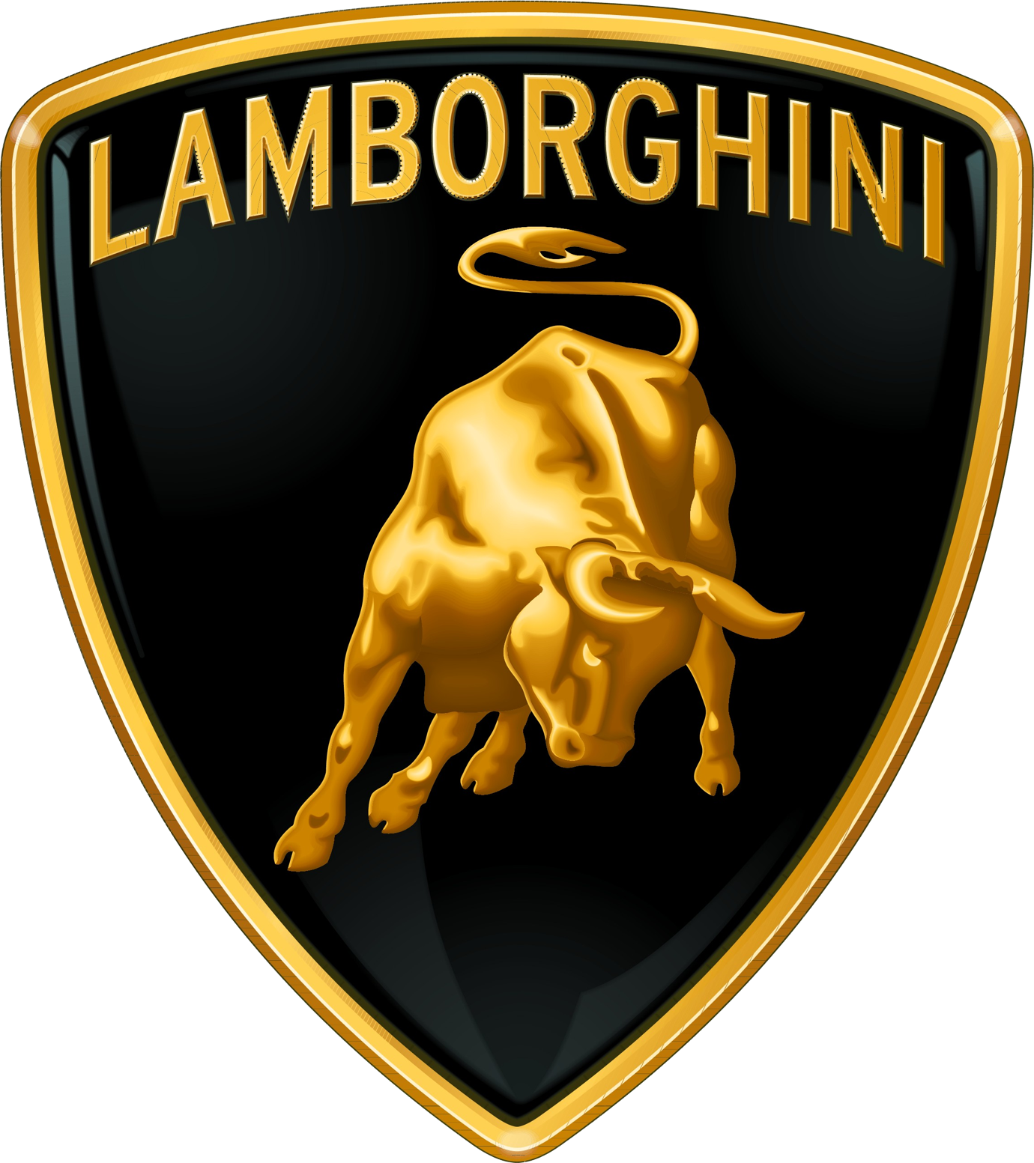

Lamborghini, often referred to as "Lambo," stands as an emblem of luxury and high-performance engineering. Founded in 1963 by Italian industrialist Ferruccio Lamborghini to rival Ferrari, the company quickly earned a reputation for its innovative designs and powerful machines.

### **The Early Years**

Lamborghini’s debut models, like the **350 GT**, set the stage for its legacy, but the groundbreaking **Miura** in 1966 cemented its place in automotive history. Featuring a rear mid-engine, rear-wheel drive layout, the Miura became a blueprint for modern sports cars.

### **Modern Masterpieces**

Today, Lamborghini produces cutting-edge vehicles like:

* The **Huracán**, powered by a V10 engine, blending performance with sleek design.
* The **Urus SUV**, showcasing versatility with its twin-turbo V8 engine.
* The **Revuelto**, a revolutionary V12/electric hybrid that symbolizes Lamborghini’s vision for the future.

### **Beyond Automobiles**

Lamborghini’s engineering excellence extends to **V12 engines for offshore powerboats** and its historic **Lamborghini Trattori** division, which has been producing tractors since 1948.

**HISTORY**

**Lamborghini**

**The Pinnacle of Italian Performance and Luxury**

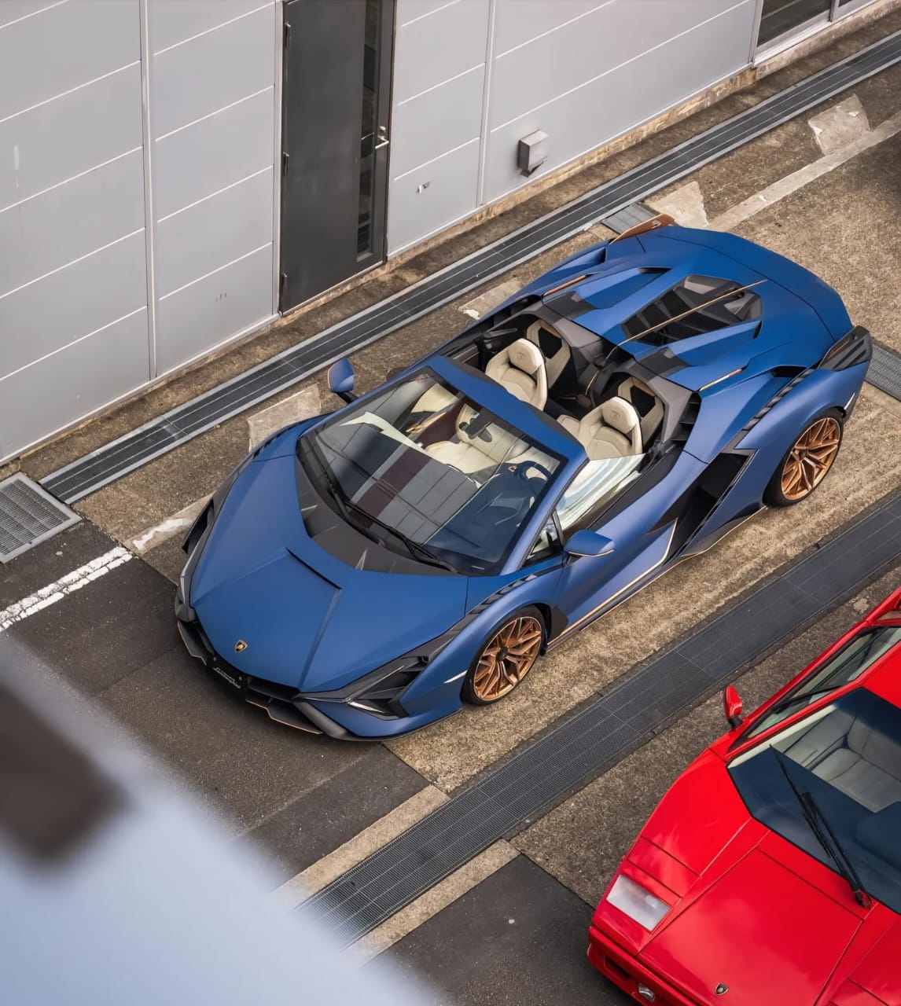**Ownership through the Years**

Lamborghini has had a diverse ownership journey:

* **1963–1972**: Founded and initially managed by Ferruccio Lamborghini.
* **1972–1987**: Changed hands multiple times, including a period under receivership**1987–1994**: Managed by Chrysler Corporation, furthering its global presence.
* **1995–1998**: Acquired by MegaTech and other investors.
* **1998–Present**: Owned by the Volkswagen Group through Audi, ensuring consistent innovation and prestige.

From tractors to hyper cars, Lamborghini’s evolution reflects its commitment to pushing the boundaries of luxury, speed, and engineering excellence.

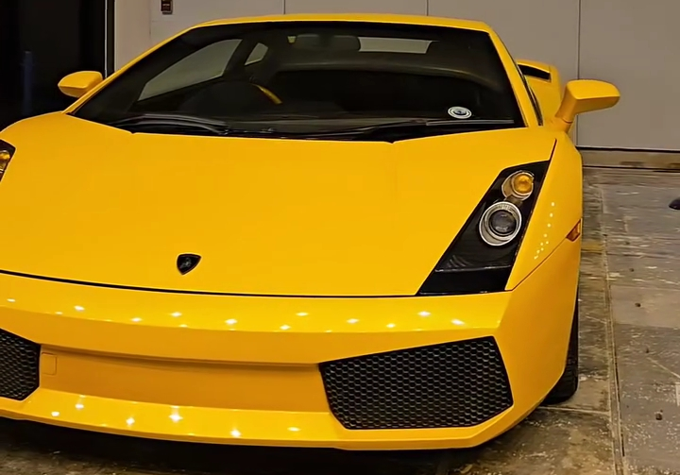

**Unrivaled Legacy and Uniqueness**

* **A Legacy Built on Challenge**  
  Lamborghini was born out of Ferruccio Lamborghini's determination to rival Ferrari after a disagreement with Enzo Ferrari. This competitive spirit not only defined its origin but also its approach to automotive excellence.
* **Tractors to Supercars**  
  From humble beginnings making tractors, Lamborghini evolved into a brand that redefined luxury sports cars. This transition highlights Ferruccio's visionary leadership and adaptability.
* **Innovative Showmanship**  
  The first Lamborghini, the 350 GTV, was presented at an auto show without an engine—a bold move that demonstrated Ferruccio’s confidence in the brandspotential.

### **Why Lamborghini is Special?**

6

* **Founder’s Vision:** Ferruccio Lamborghini’s passion and drive laid the foundation for a brand that continues to innovate.
* **Uncompromising Performance:** With powerful V10 and . V12 engines, Lamborghini sets the gold standard for . speed and thrill.
* **Avant-Garde Design:** Each car is a testament to creativity, . inspired by everything from fighter jets to nature’s most . intricate forms.
* **A Global Icon:** Lamborghini isn’t just a car brand; it’s a symbol of status, innovation, and passion that resonates worldwide

7



7

Mercedes-Benz commonly referred to simply as **Mercedes** and occasionally as **Benz**, is a German luxury and commercial vehicle brand that was found in 1926. **Mercedes-Benz AG** (a subsidiary of the Mercedes-Benz Group, established in 2019) is based in **Stuttgart**, **Baden-Wurttemberg**, Germany. Mercedes-Benz AG manufactures luxury vehicles and light commercial vehicles, all branded under the Mercedes-Benz name. From November 2019 onwards, the production of Mercedes-Benz-branded heavy commercial vehicles (trucks and buses) has been managed by **Daimler Truck**, which separated from the Mercedes-Benz Group to from an independent entity at the end of 2021.



**Mercedes-Benz Founders:**

* Karl Benz
* Gottlieb Daimler

**Specialty Vehicles:**

**SPECIALTY VEHICLES:**

These cars from Mercedes-Benz that stand out for their innovation, exclusivity, and performance:

* Mercedes-Benz 300 SL “Gullwing”
* Mercedes-Benz SLR McLaren
* Mercedes-Benz G 63 AMG

These cars from Mercedes-Benz that stand out for their innovation, exclusivity, and performance:

* Mercedes-Benz 300 SL “Gullwing”
* Mercedes-Benz SLR McLaren
* Mercedes-Benz G 63 AMG

**What makes Mercedes-Benz Special?**

1. **Innovative Technology:** Mercedes-Benz is a leader in introducing cutting-edge technologies, such as MBUX infotainment, advanced driver assistance systems, and autonomous driving features, ensuring both safety and a futuristic driving experience.
2. 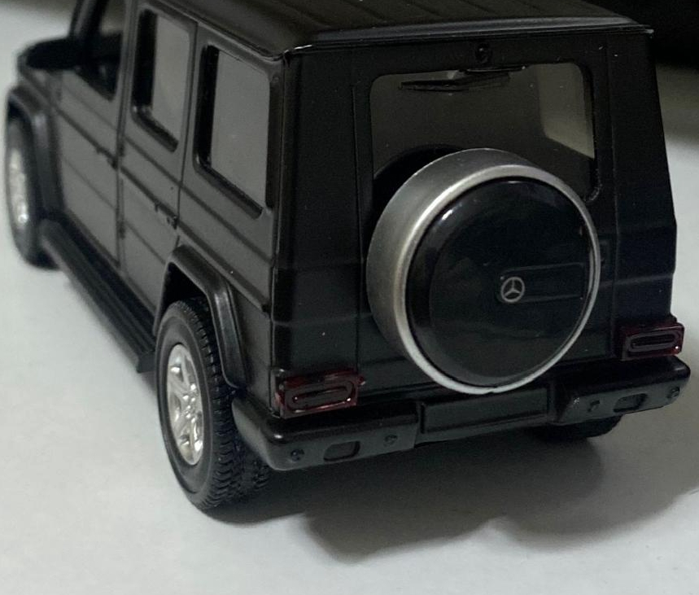**Unmatched Luxury and Comfort:** The brand is known for itsexceptional build quality, premium materials, and comfort-focused features like massage seats, ambient lighting, and top-tier sound systems, creating an unparalleled driving environment.



# 

9

9

SUSTANIBILTY

Audi

Audi takes economic, ecological and social responsibility and has made sustainable business operations an integral part of all its decisions and products.

Audi is german manufacturer of luxury cars. The company is based on latin translation of surname of the founder August Horch.The company was originally established in 1885.

In mid to late 1990s, Audi introduced new technologies including the use of aluminium construction.

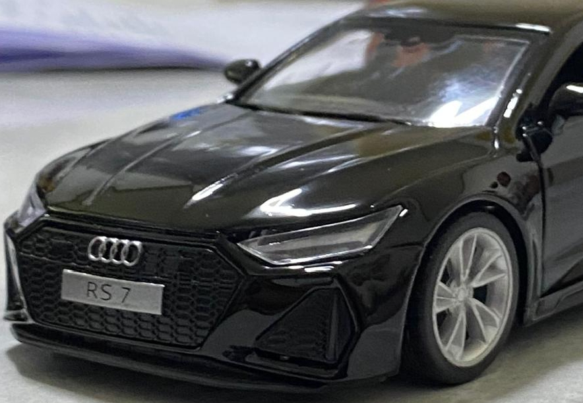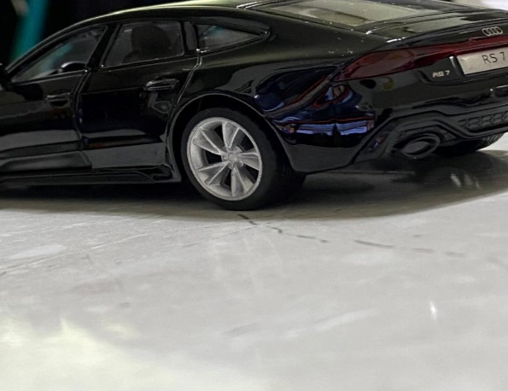

SPACE FRAME TECHNOLOGY:  
Audi introduced space frame technology which saves weight and improves torsion rigidity compared to conventional steel frame. It is quite expensive to repair and requires specialized aluminium bodyshop.

BODY SHELLS:  
Audi produce galvanized cars. Full body zinc coating has proved

Very effective in preventing rust.  
POWERFUL ENGINES:

To be able to mount powerful engines, Audi has engineered

its cars with longitudinally front-mounted engines in an

overhung position over the front wheels infront of axle

line. Audi had led the development of inline four engine families.

SYNTHETIC FUELS:  
Audi assisted with technology to produce synthetic diesel from carbondioxide and water.

Two principal plants in Germany are:

* Ingolstadt
* Neckarsulm

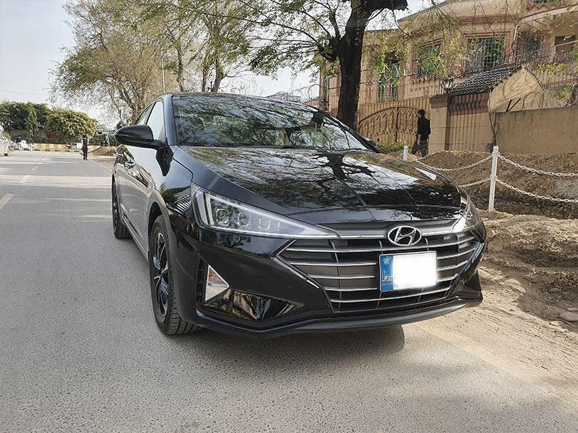

10

HYUNDAI

**INTRODUCTION**

The Hyundai is South Korean multinational automotive manufacturer headquartered in Seoul, South Korea.It was founded in 1967. Hyundai vehicles are sold in 193 countries through 5000 dealerships and showrooms. It is world’s third largest carmaker in terms of production and falling behind competitors.

**Founder:**

Chung-Ju-Yung founded the Hyundai engineering and Construction company in 1947.

**Research and Development:**

Hyundai has six research and development centres in the world.Located in South Korea (three offices), Germany, Japan and India.

**Product Line:**

Hyundai produces Sedans, hatchbacks, cross overs, vans, pickups, heavy trucks and busess

Engine:

Hyundai was the first one to introduce BS6-compilant turbo-petrol engine.

Safe cars:

Hyundai cars are known to be pretty safe with rigid body structure, well placed crumple zones, emergency stop signals, airbags.

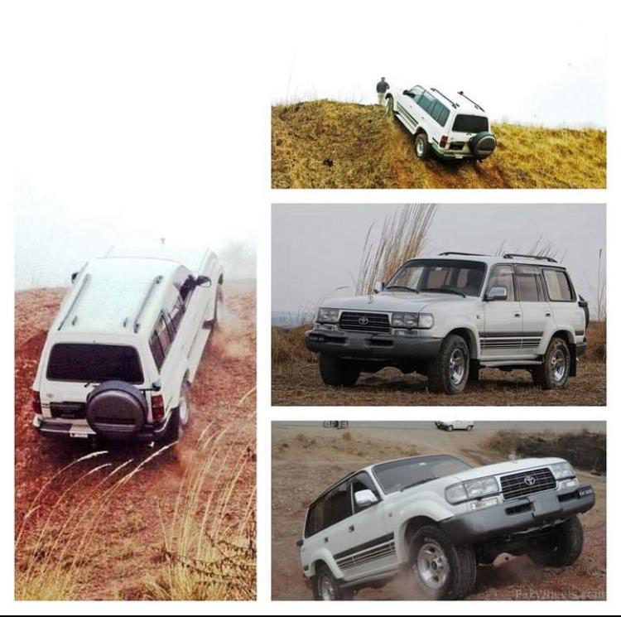

**1. Reliability:**

Toyota is known for producing vehicles that require minimal repairs and maintenance. Their reputation for reliability is one of the main reasons many buyers choose Toyota.

**2. Fuel Efficiency:**

With a focus on providing economical vehicles, Toyota offers several models, such as the Corolla, Prius, and Camry, which is praised for their impressive fuel efficiency.

**3. Safety:**

Toyota prioritizes safety across its vehicle lineup. Many models come equipped with Toyota Safety Sense, a suite of safety technologies that includes pre-collision systems, lane departure alerts, and adaptive cruise control.

**4. Affordability:**

Toyota cars are generally considered affordable, offering great value for money. This extends to both initial purchase price and long-term maintenance costs, contributing to strong resale values.

**5. Advanced Technology:**

Toyota has integrated various technologies into its vehicles, including hybrid powertrains, cutting-edge infotainment systems, and semi-autonomous driving features. The introduction of Toyota's hybrid and hydrogen fuel cell technologies has positioned the company as a leader in alternative fuel vehicles.

**6. Comfort and Design:**

Toyota combines practicality with comfort in its vehicles. While they may not always be as luxurious as other brands, models like the Toyota Highlander, Avalon, and Lexus models offer premium features and refined interiors.

**7. Environmental Commitment:**

The Prius remains one of the most popular hybrid cars, symbolizing Toyota's commitment to reducing carbon emissions and reliance on fossil fuels. Toyota also plans to invest heavily in electric vehicles and hydrogen technology in the coming years.

MADE BY:

**AYESHA MEHMOOD, ALISHBA SHAFQAT, NIMRA ALI,**

**DARAIN ZAHRA, ZARA RANI**

THE RIDE

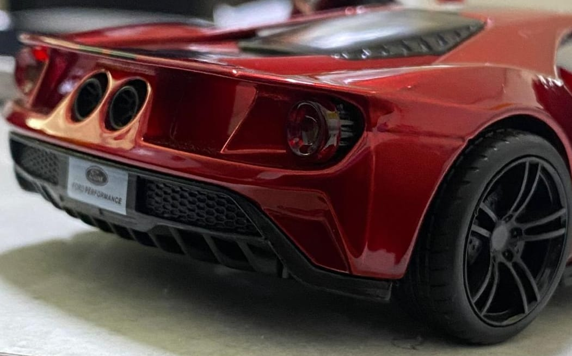



FACEBOOK: @beyondthegear

INSTAGRAM: @beyondthegear  
x: @beyondthegear

EMAIL: beyondthegear@gmail.com

11